PROCESS MANAGEMENT

Q1. How will you put a process to sleep for 300 seconds in the background?

ANSWER: sleep 300&



Q2. How will you bring the above sleep process into

the foreground and then send it back to the

background?

ANSWER: fg 6 bg 6

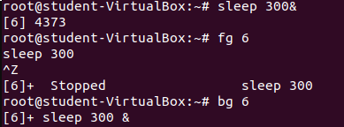

Q3. How will you kill the above sleep process?

ANSWER: kill -9 (processed)

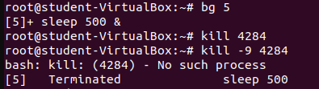

Q4. How will you list the CPU and memory utilization of the process

started by the user ‘chrony’?

answer: top –u chrony



Q5. How will you kill all the processes

started by user ‘chrony’?

ANSWER: pgrep –l –u chrony 